DIS-US-IL-Mississippian-Ceremonial sword-Mill Creek Chert

**Ceremonial Sword, 6.75 in. length, Dover Flint, ca. 1200-1350 CE.**

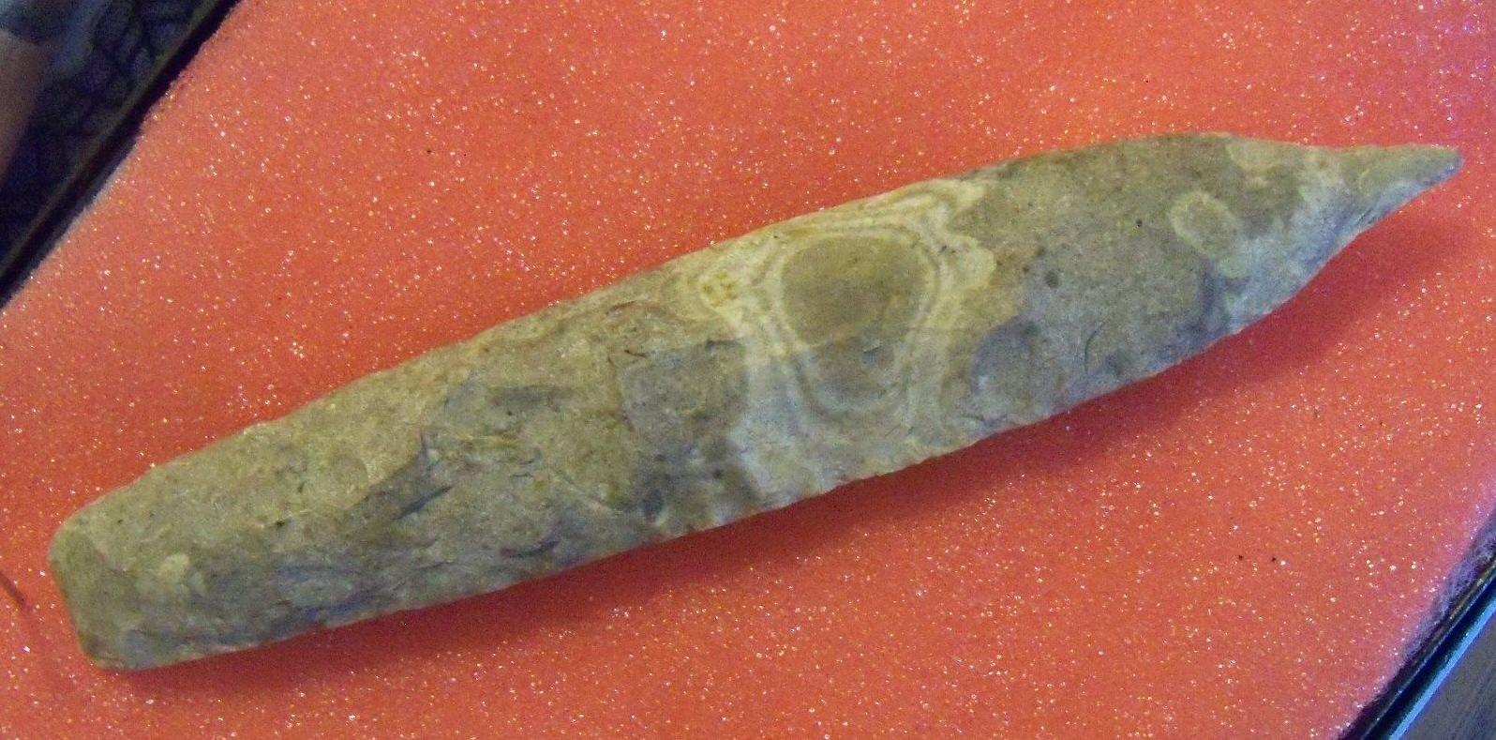 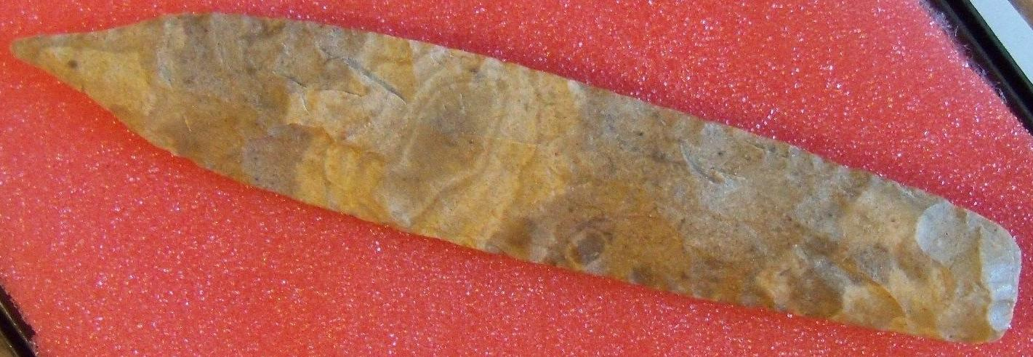

# Duck River Sword-Form Flint Biface

**A large, narrow, ceremonial blade with a rounded base and a mucronate tip (ending abruptly in a short sharp point or mucro). Made by the Mississippians and used in their Eagle dances, as depicted on their shell gorgets, particularly at the Great Busk festival in the fall. The famous Duck River cache of this type was found in the 1890's on the Duck River in Tennessee with lengths up to 30 inches. All are made of Dover flint.** A.D. 1200 and f350 CE (**Neitzel and Jennings** 1995:410-4f4).

Two types of Duck River chipped stone bifaces are depicted on the Hightower anthropomorphic-style marine shell gorgets. One type is the "Duck River Sword," a long, thin sword-form thin biface with rounded, **mucronate**, or multiple triangular points (**Brown 1976b:158; Perino 1985:108**). The other type is the raptor talon effigy biface. Both biface types have been found in archaeological contexts in the mid-South and appear to have been knapped from flint similar to examples mined from the Dover quarries in Stewart County, Tennessee (**Gramly 1992**). Some of the best-known examples of these two forms are represented in the Duck River cache, discovered at the Link Farm site in 1894 in Humphreys County, Tennessee (Marceaux and Dye. 2007: 175). The cache contains multiple sword-form bifaces and raptor talon effigy bifaces in addition to other flaked stone symbols (**Brehm 1981**). 15 Duck River sword-form bifaces were found in mortuary contexts and in the Upper Tennessee Valley five examples of Duck River sword-form Dover flint bifaces were recovered from the Late Hiwassee Island or Early Dallas phase contexts at the Hixon site. The stratigraphic position of the burials and accompanying blades suggests they were interred between 1200 and f350 CE (**Neitzel and Jennings 1995**: 410-4f4). This was in a period of great economic stress at the beginning of the downturn in climate at the end of the Neo-Atlantic Altithermal Climatic Period and the beginning of the Pacific Climatic Period.

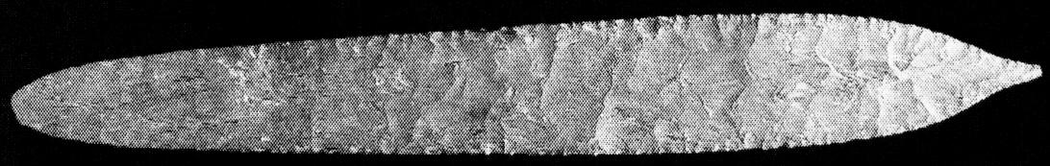

**Sword-Form Flint Biface, with a rounded base and a mucronate tip, Humphrey's County, Tennessee. Photo, David H. Dye in Marceaux and David Dye. 2007.**

# SHAPE \* MERGEFORMAT

# Ceremonial chipped flint "swords" from the Craig Mound At Spiro Mounds. The longest is 17" (43.2 cm.) photograph by Robert Bell in August of 1935. It shows seven of the large "Spiro swords" that were found together in a cache.

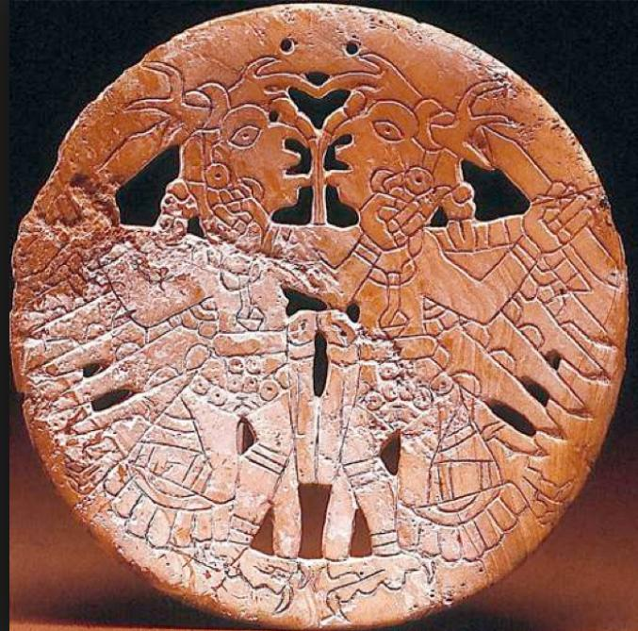

**Anthropomorphic-style, mortal combat theme, marine shell gorget, Hixon site, Hamilton County, Tennessee ca. 1200-1350 CE showing birdman, raptor-winged, deer-horned warriors holding Duck River flaked stone bifaces. Frank H. McClung Museum, University of Tennessee.**

These **birdman, raptor-winged, deer-horned warriors** wield **Duck River flaked stone bifaces** raised above the shoulder emphasizing display and combat. The engravers of the mortal combat gorgets situated the stone bifaces in a smiting context, alluding to human sacrifices or their re-enactments by deities locked in mortal combat. The gorgets and the sword-form bifaces were made near the time of gorget manufacture with sword-form bifaces dating as early as 1200 CE and gorgets manufactured no earlier than 1250 CE. The mortal combat theme suggests trophy-taking behavior (**Childress and Wharty 1996; Nash 1972**) illustrated iconographically by trophy heads incorporated as headdress elements (**Burnett 1945:**Plate 74; **Hamilton et al. 1974**:figure 70). **1978**:146, Plates 2, 17, Figure 106). All of the shell gorgets and flaked stone bifaces recovered archaeologically have been found in mortuary contexts along with prestige goods, representing chiefly élites who had attained exalted status through inherited or achieved rank, mainly through prowess in warfare.

**Brehm, H. C. 1981. *The history of the Duck River Cache*. Miscellaneous Paper no. 6. Knoxville: Tennessee Anthropological Association.**

**Brown, J. A. 1976. Spiro Studies, vol. 4: the artifacts. Norman: University of Oklahoma Research Institute.**

**Burnett, E. K. and Forrest E Clements. 1945. The Spiro Mound collection in the museum. New York : Museum of the American Indian, Heye Foundation**

**Childress and Wharty 1996;**

**Gramly, R. M. 1992. Prehistoric lithic industry at Dover, Tennessee. New York: Persimmon Press.**

**Hamilton, H. W. and Jean T. Hamilton and Eleanor E. Chapman. 1974. Spiro Mound copper. Memoir 11. Columbia: Missouri Archaeological Society.**:

# Marceaux, Shawn and David H. Dye. 2007. Hightower anthropomorphic marine shell gorgets and Duck River Sword-Form flint bifaces: Middle Mississippian ritual regalia in the southern Appalachians in Adam King, David H. Dye and Jon Muller, eds. *Southeastern Ceremonial Complex: Chronology, Content, Contest.* Birmingham: University Alabama Press.

**Nash, C. 1972. Chucalissa: excavations and burials through 1963. Occasional papers, no. 6. Memphis: Anthropological Research Center, University of Memphis.**

**Neitzel, R. S. and J. D. Jennings. 1995. The Hixon Site. In The prehistory of the Chicamauga Basin in Tennessee, vol. 2, compiled and edited by T M. N. Lewis, M. K. Lewis and L. P. Sullivan, pp. 305-371. Knoxville: University of Tennessee Press.**

**Perino, G. 1985. Selected preforms, points and knives of the American Indians, vol. 1. Idabel, Oklahoma: Points and Barbs Press.**

### Delivery package 1 of 1

Estimated delivery Saturday, Sep 26, 2015

#### [Duck River Sword-Mississippian Culture Ceremonial- Arrowhead-6 3/4"](http://www.ebay.com/itm/381411704039)

|  |  |
| --- | --- |
| Item price | $29.99 |
| Quantity | 1 |
| Item number | 381411704039 |
| Shipping service | USPS Priority Mail Small Flat Rate Box |